**Funnel Analysis – Oleksandr Levchenko – 16.05.2017**

Goal: Complete funnel analysis and discover any significant facts which can improve the conversation rate

Data: 5 csv tables with user’s statistics

Steps:

1. Data import and general analysis
   1. About 90400 of users visited our web page between January and April 2015
   2. About 66% used desktop application and 33% - mobile application
   3. About 50% of all users were woman, and 50% - men

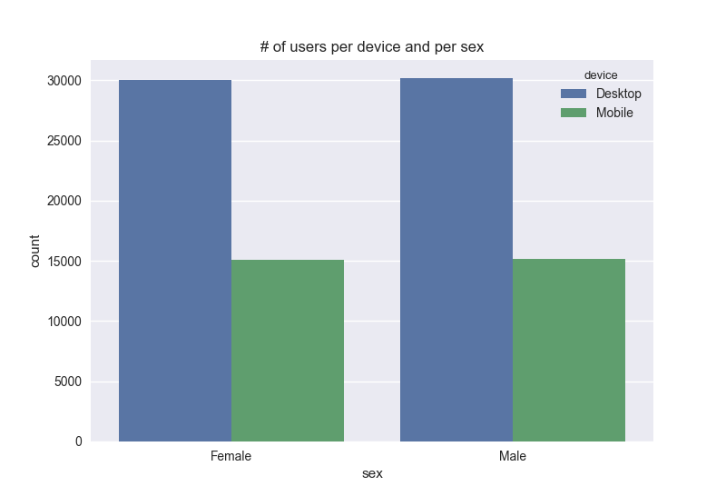

1. Use of Desktop application vs Mobile application – General Analysis
   1. Observations
      1. Only half of users who visited home page landed to the search page
      2. About 20 % of mobile app users who visited search page went to the payment page (vs. 10% of desktop app users)
      3. About 10% of mobile app users who visited the payment page confirmed the payment (vs. 5% of desktop app users)
      4. There is no significant difference whether the users are male of female (see table below)

|  |  |  |  |  |  |  |  |  |
| --- | --- | --- | --- | --- | --- | --- | --- | --- |
|  |  |  |  |  |  |  |  |  |
|  |  | home | search |  | payment |  | confirmation |  |
| **device** | month | # of users | # of users | % users in current page to previous | # of users | % users in current page to previous | # of users | % users in current page to previous |
| Desktop | 1 | 15050 | 7529 | 50,03% | 1221 | 16,22% | 60 | 4,91% |
|  | **2** | **15050** | **7632** | 50,71% | **1191** | **15,61%** | **54** | **4,53%** |
|  | 3 | 15050 | 7370 | 48,97% | 296 | 4,02% | 14 | 4,73% |
|  | 4 | 15050 | 7569 | 50,29% | 302 | 3,99% | 22 | 7,28% |
|  | Total | 60200 | 30100 | 50,00% | 3010 | 10,00% | 150 | 4,98% |
| Mobile | **1** | **7550** | **6025** | 79,80% | **1169** | **19,40%** | **129** | **11,04%** |

1. Use of Desktop application vs Mobile application – Per month
   1. Observations
      1. There is no significant difference in overall use of desktop and mobile application in each month

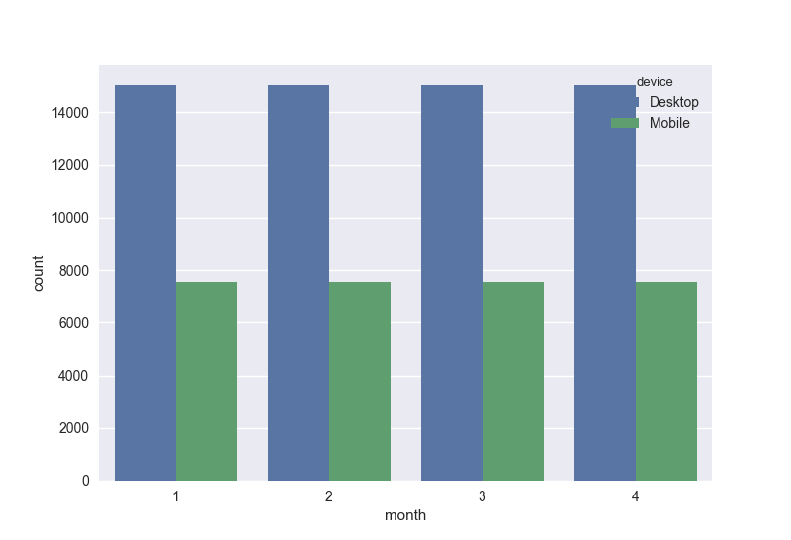

* + 1. There is a significant drop in # of mobile application users who landed on the search page starting from March 2015 (See table below)
    2. There is a significant drop in # of desktop application users who landed on the payment page starting from March 2015 (See table below)

|  |  |  |  |  |  |  |  |  |
| --- | --- | --- | --- | --- | --- | --- | --- | --- |
|  |  | **home** | **search** |  | **payment** |  | **confirmation** |  |
| **device** | month | # of users | # of users | % users in current page to previous | # of users | % users in current page to previous | # of users | % users in current page to previous |
| **Desktop** | 1 | 15050 | 7529 | 50,03% | 1221 | 16,22% | 60 | 4,91% |
|  | 2 | 15050 | 7632 | 50,71% | 1191 | 15,61% | 54 | 4,53% |
|  | 3 | 15050 | 7370 | 48,97% | 296 | 4,02% | 14 | 4,73% |
|  | 4 | 15050 | 7569 | 50,29% | 302 | 3,99% | 22 | 7,28% |
|  | **Total** | **60200** | **30100** | **50,00%** | **3010** | **10,00%** | **150** | **4,98%** |
| **Mobile** | 1 | 7550 | 6025 | 79,80% | 1169 | 19,40% | 129 | 11,04% |
|  | 2 | 7550 | 6055 | 80,20% | 1221 | 20,17% | 119 | 9,75% |
|  | 3 | 7550 | 1509 | 19,99% | 335 | 22,20% | 30 | 8,96% |
|  | 4 | 7550 | 1511 | 20,01% | 295 | 19,52% | 24 | 8,14% |
|  | **Total** | **30200** | **15100** | **50,00%** | **3020** | **20,00%** | **302** | **10,00%** |

1. Recommendations
   1. There are more users who use desktop application, but % of them who complete the whole funnel and buy a product at the end is less than across the users of mobile application. Especially we have significant drop on the search and payment page - > Improve the usability of search page and make the payment page more simple
   2. Discover why the users of desktop application leave our search page much more often starting from March (maybe new features were introduced)
   3. Discover why the users of mobile application leave our home page much more often starting from March (maybe new features, maybe there is some connection between b. and c.)